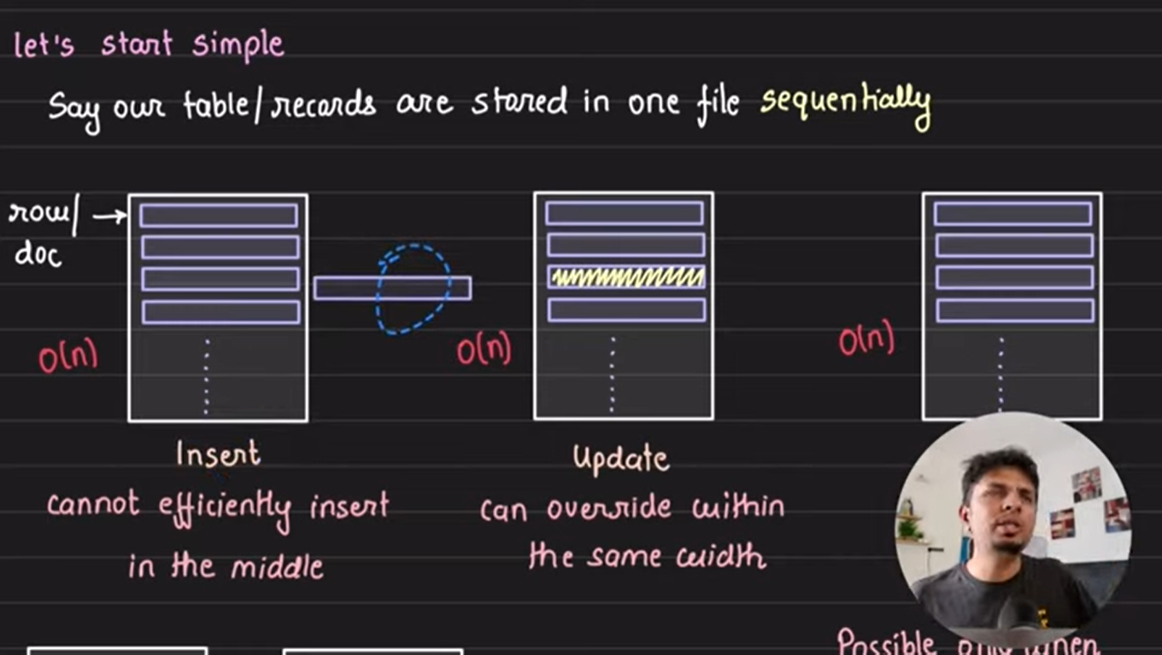



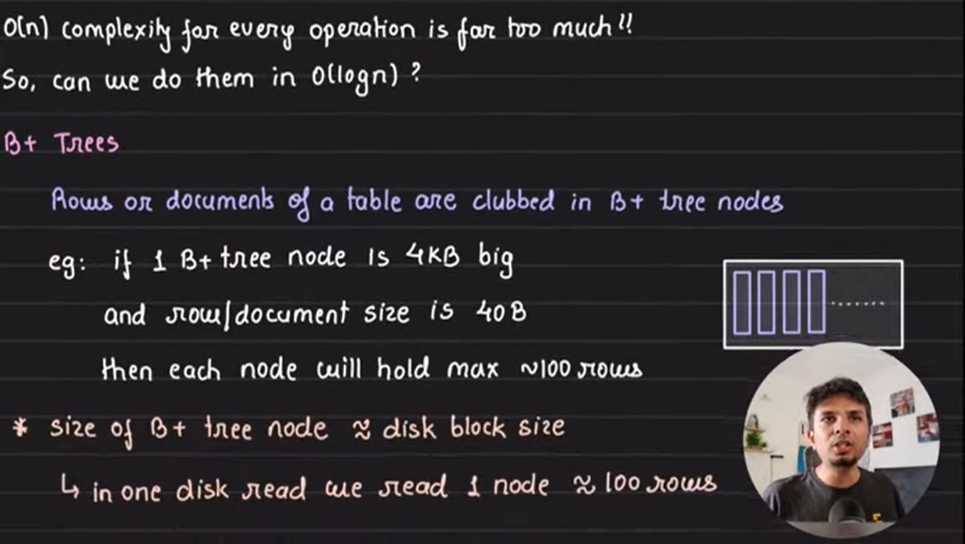

**Why Use B+ Tree?**

1. B+ Trees are the best choice for storage systems with sluggish data access because they minimize I/O operations while facilitating efficient disc access.
2. B+ Trees are a good choice for database systems and applications needing quick data retrieval because of their balanced structure, which guarantees predictable performance for a variety of activities and facilitates effective range-based queries.

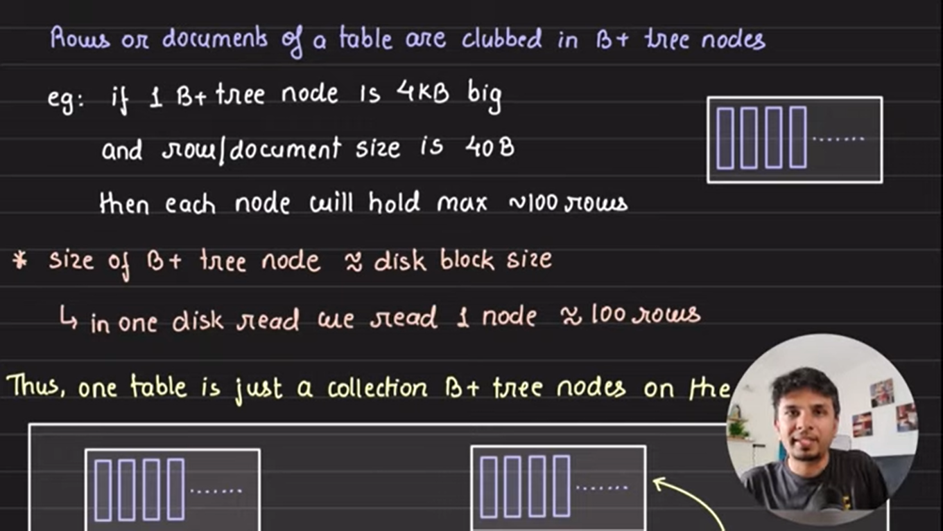

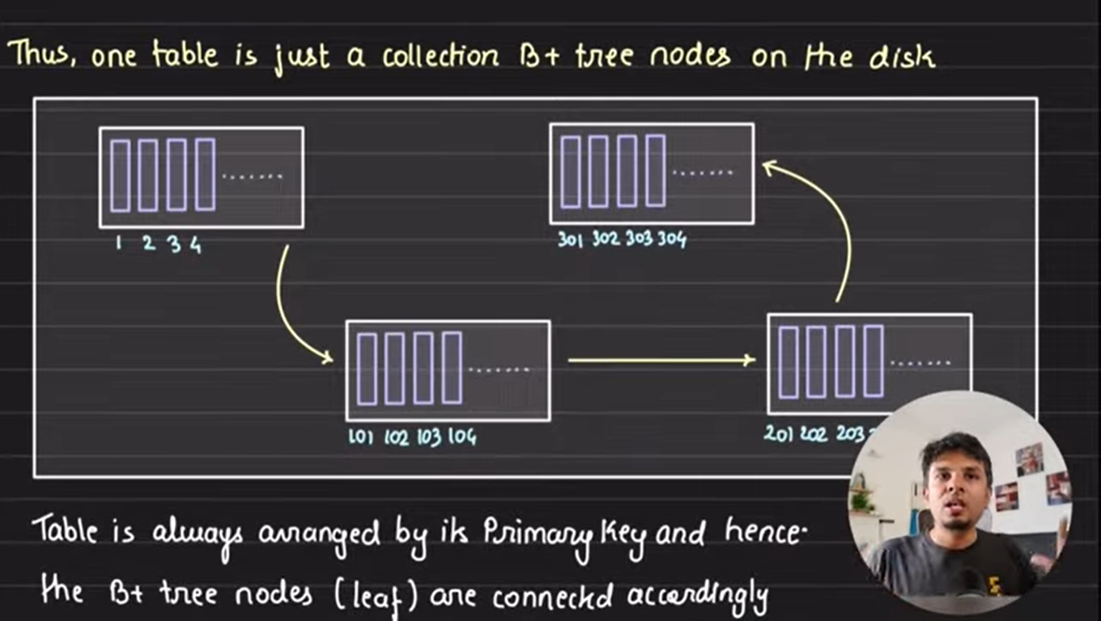

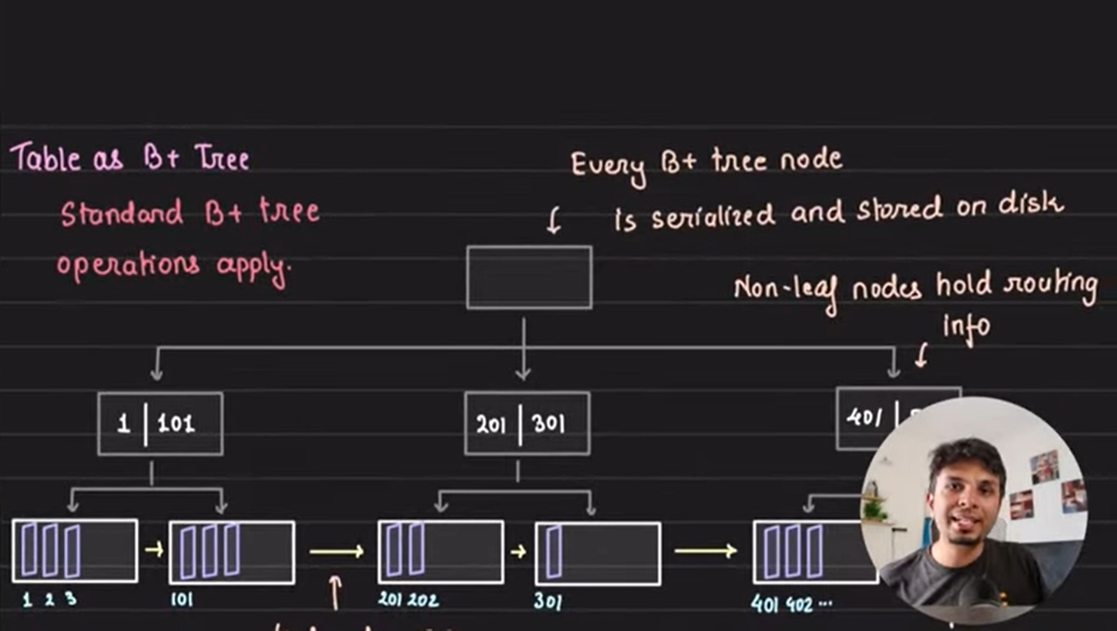

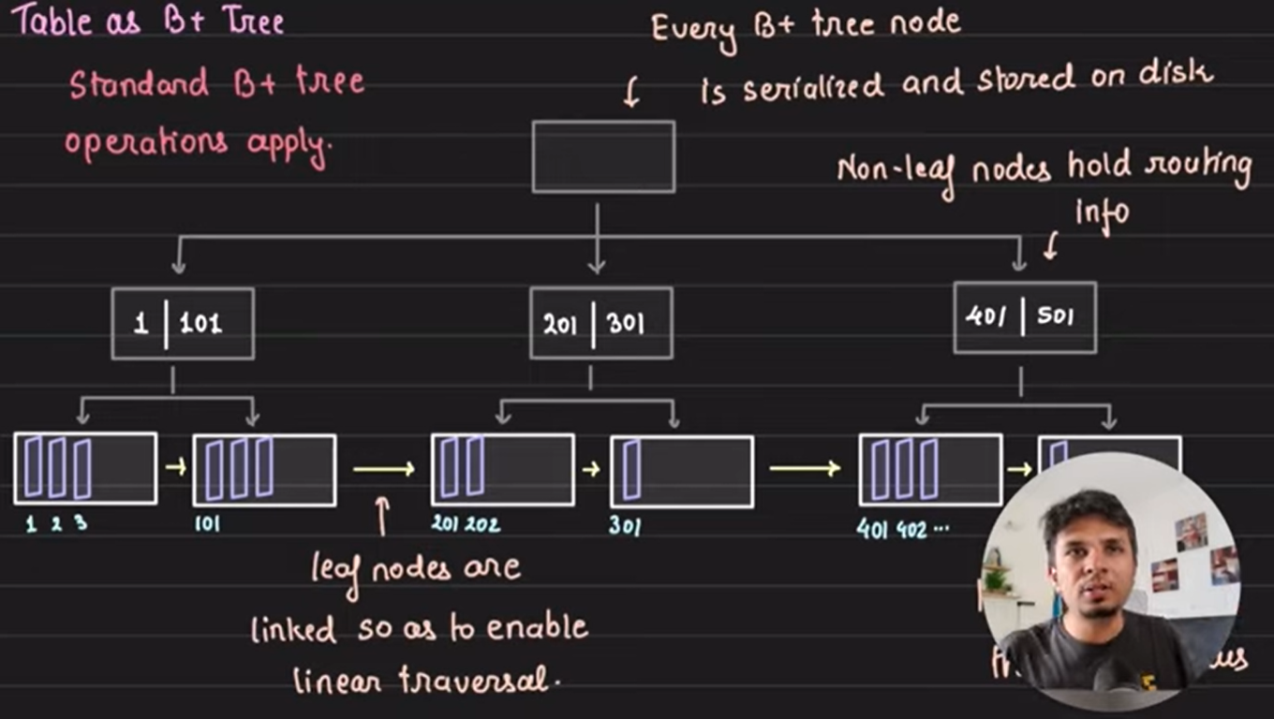



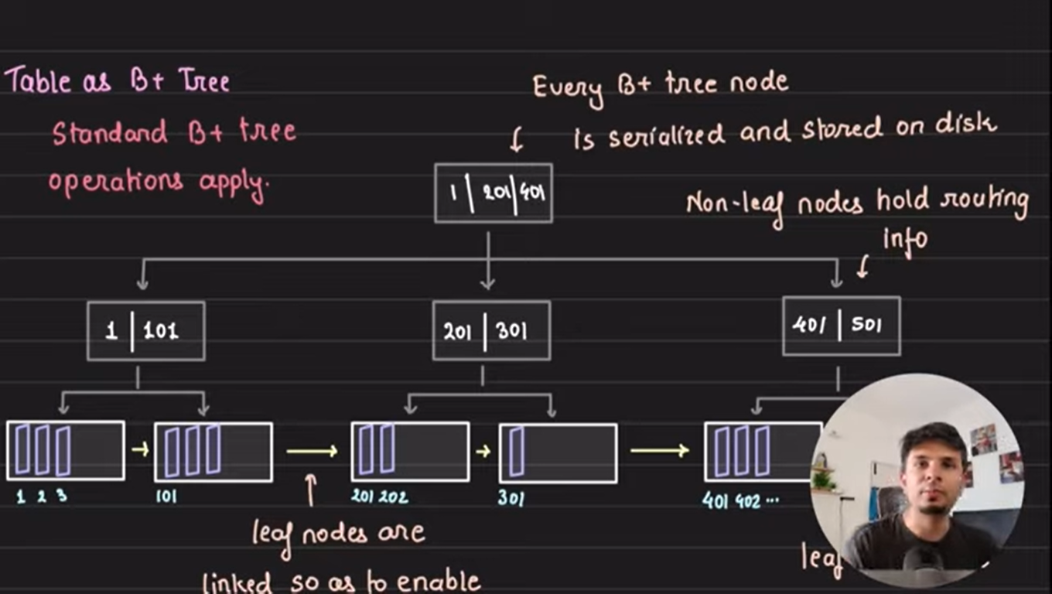

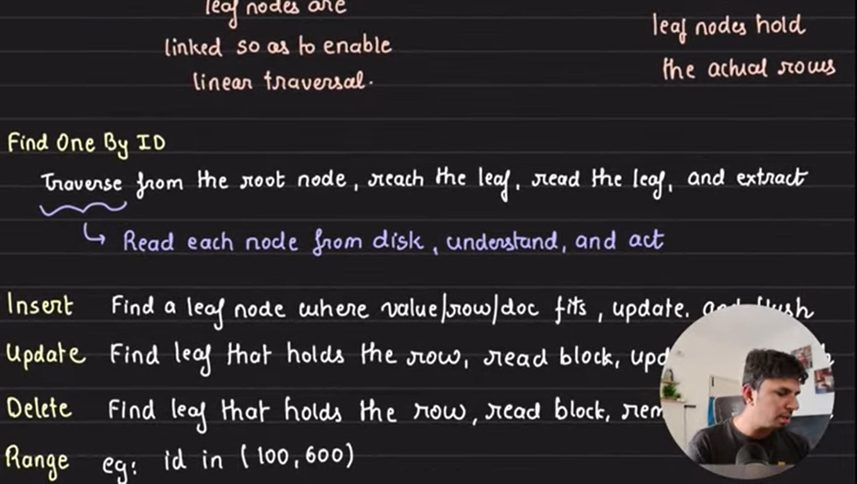

update inmemory in flush it to disk

read linearly as leaf nodes are connected

